**Smart Patients Monitoring Application**

**Developed by:**

**Group Members**

**Ayesha Nazir (BO461259)**

**Maryam Bibi (BO460830)**

**Supervised by**

**Sir Saqib Subhan**

**Department of Computer Science**

**Allama Iqbal Open University**

**H-8, Islamabad**

**Year 20****21**

**DECLARATION**

I at this moment declare that this Application, “**[Smart Patients Monitoring Application]**” neither as a whole nor as a part, therefore, has been copied out from any source. It is further declared that I developed this Application and this report entirely by our efforts made under the sincere guidance.

If any part of the system is proved to be copied out from any source or found to be a report of some other, we shall stand by the consequences.

No portion of the work presented in this report has been submitted insupport of any application for any other degree or qualification of this or any other university or institute of learning.

We further declare that this Application and all associated documents, reports, and records are submitted as partial requirements for the degree of BS (CS-GPA). We understand and transfer copyrights for this material to Allama Iqbal Open University, Islamabad.

We shall not sell this software and document and not get any financial gains from these.

***-----------------------------------------------***

**Project Supervisor**

Mr. Saqib Subhan

**FINAL APPROVAL**

This is to certify that we have read the project report submitted by **Ayesha Nazir** and **Maryam Bibi** and we recommend that this report is of sufficient standard to warrant its acceptance by Allama Iqbal Open University, Islamabad, for BS (CS-GPA) degree.

**Examination Committee**

|  |  |  |  |
| --- | --- | --- | --- |
| Internal Supervisor |  |  | Mr. Saqib Subhan |
| Designation |  |  | Lecturer |
| Study Center |  |  | Buraq Institute of Science and  Technology |
| Signature |  |  | _________________________ |
| **Internal Examiner** |  |  | Mr. Saqib Subhan |
| Designation |  |  | Principal |
| Study Center |  |  | Buraq Institute of Science and  Technology |
| Signature |  |  | _________________________ |
| **External Examiner** |  |  | Ch. Muhammad Shahbaz |
| Designation |  |  | Lecture, DCS, AIOU |
| Signature |  |  | _________________________ |

**ACKNOWLEDGEMENT**

First of all, I express our gratitude to Almighty Allah, the merciful, the compassionate and the creator of the whole universe, on the completion of my BS studies. It was not possible for me without His blessing upon me. I offer my humblest words of thanks to the Holy Prophet Hazrat Muhammad (Peace be upon him) who is forever a torch of guidance for humanity.

This is a great opportunity for me to express my feelings of love and gratitude to my teacher and supervisor **Mr. Saqib Subhan** for remaining a constant source of inspiration to us. I am highly impressed by his nice behavior and kindness.

I am very thankful to him for his devotion, commitment and help during our project.

I am especially like to thank BS fellows for their dedication and hard work for the completion of my project. They are very kind, helpful and cooperative with me to complete this work.

**PROJECT IN BRIEF**

**Project Title**

Smart Patients Monitoring Application

**Organization (if any)**

For Every Patient

**Objectives**

To provide the information of women to her parents and other family members

**Developed by**

Ayesha Nazir

Maryam Bibi

**Supervised By**

Sir Saqib Subhan

**Tools Used**

Android Studio

Arduino IDE

**Operating System**

Window 10

**System Used**

HP core i5 4th Generation

**ABSTRACT**

Nowadays Health-care Environment has developed science and knowledge based on Wireless-Sensing node Technology oriented. Patients are facing a problematic situation of unforeseen demise due to the specific reason of heart problems and attack which is because of nonexistence of good medical maintenance to patients at the needed time.

This is for specially monitoring the old age patients and informing doctors and loved ones. So, we are proposing an innovative project to dodge such sudden death rates by using Patient Health Monitoring that uses sensor technology and uses internet to communicate to the loved ones in case of problems. This system uses Temperature and heartbeat sensor for tracking patient’s health. Both the sensors are connected to the Arduino-uno.

To track the patient health micro-controller is in turn interfaced to an LCD display and bluetooth connection to send the data to the web-server (wireless sensing node).

In case of any abrupt changes in patient heart-rate or body temperature alert is sent about the patient using IoT. This system also shows patients temperature and heartbeat tracked live data with timestamps over the Internetwork. Thus, Patient health monitoring system based on IoT uses internet to effectively monitor patient health and helps the user monitoring their loved ones from work and saves live

**TABLE OF CONTENT**

Contents

CHAPTR NO 1 1

INTRODUCTION 1

1.3 2

1.4 LITERATURE REVIEW 3

1.5 FEASIBILITY REPORT 3

1.5.2 Software Specifications: 3

1.5.3 Approximation of Time, Cost, Resources Time: 3

1.5.4 Technical Feasibility 4

1.5.5 Economic Feasibility 4

1.5.6 Operational Feasibility 4

3.4 HARDWARE SPECIFICATION: 7

3.5 SOFTWARE SPECIFICATIONS: 7

3.6 BENEFITS OF PROPOSED SYSTEM 8

3.6.1 Efficiency 8

3.6.2 Usability 8

3.6.3 Security 8

3.6.4 Privacy 8

3.6.5 Access Rights 8

3.6.6 Scalability 9

3.6.7 Maintainability 9

3.6.8 Testability 9

3.7.1 Performance 9

CHAPTER NO 4 10

SYSTEM DESIGN 10

1.2 INPUT DESIGN FOR A USER REGISTRATION PAGE 10

1.3 INPUT DESIGN FOR Women Security 12

1.4 INPUT DESIGN FOR USER POST THREADS 13

4.7.1 Admin 16

4.7.17 Notification 19

4.8 CLASS DIAGRAM 20

20

4.10 ENTITY RELATION DIAGRAM 20

CHAPTER NO 5 21

SYSTEM IMPLEMENTATIONS 21

5.1 DEFINITION OF IMPLEMENTATION: 21

5.2 IMPLEMENTATION POINTS: 21

5.2.1 Developing an Implementation Plan 22

5.2.2 Time Line for Implementation: 22

5.3.1 Waterfall Model 23

5.3.2 Analysis 24

5.4 FEASIBILITY STUDY: 24

5.5 PROGRAMMING ENVIRONMENT: 26

8.1 HOME PAGE: 38

8.13 REFERENCE AND BIBLIOGRAPHY 43

# CHAPTR NO 1

**INTRODUCTION**

**Smart Patients Monitoring Application**

# **INTRODUCTION**

The increased use of mobile technologies and smart devices in the area of health has caused great impact on the world. Health experts are increasingly taking advantage of the benefits these technologies bring, thus generating a significant improvement in health care in clinical settings. Likewise, countless ordinary users are being served from the advantages of the M-Health (Mobile Health) applications and E-Health (health care supported by ICT) to improve, help and assist their health.

According to the constitutions of World Health Organization (WHO) the highest attainable standard of health is a fundamental right for an individual. As we are truly inspired by this, we attempt to propose an innovative system that puts forward a smart patient health tracking system that uses sensors to track patient vital parameters and uses internet to update the doctors so that they can help in case of any issues at the earliest preventing death rates.

Patient Health monitoring using IoT is a technology to enable monitoring of patients outside of conventional clinical settings (e.g. in the home), which may increase access to care and decrease healthcare delivery costs. This can significantly improve an individual's quality of life. It allows patients to maintain independence, prevent complications, and minimize personal costs. This system facilitates these goals by delivering care right to the home. In addition, patients and their family members feel comfort knowing that they are being monitored and will be supported if a problem arises

**1.2 PROBLEM DEFINITION**

Patients monitoring is a critical issue and it is much needed for every individual to act over such issue to safeguard their family members and themselves. When safety and security is concerned, a smart phone can become a powerful tool to prevent any kind of medical related issue. Keeping this in mind, an android app has been developed which is dedicated to provide relief to the person in trouble.

1.3SCOPE OF THE PROJECT

For the Android Application that will keep all these steps which are as follows:

* Record patient health readings.
* Read runtime patients heartbeat readings
* Read runtime patients temperature
* Buzzer on exceeding or heartbeat from normal readings as per the age group
* User can define age group according to which heartbeat ratings will be recorded
* User can alert doctors or trustees through sms containing readings alert

Types of user will interact with **Smart Patients Monitoring Application**.

**1.3.1 Sign-in**

* The first-time users have to login to the app by entering the basic details of the user like Email and password.
* User will enter his age group and also enter his gender.
* Doctors will be able to see patient’s readings by sitting remotely.
  + 1. **At emergency situations**
* There is an sms alert. On exceeding heartbeat limit the sms alert will be activated which will get the attention of nearby.

## LITERATURE REVIEW

Flexible and scalable patient’s health monitoring system in 6LoWPAN . The main advantage of this enabling factor is the combination of some technologies and communications solution. The results of Internet of Things are synergetic activities gathered in various fields of knowledge like telecommunications, informatics and electronics.

Maintaining sensing coverage and connectivity in large sensor networks mainly includes the information about how to build or develop a new computational technology based on clinical decision support systems, information processing, wireless communication and also data mining kept in new premises in the field of personal health care.

## 1.5 FEASIBILITY REPORT

This “Filtering the comments: Sentiment Analysis of Smart Patients Monitoring Application is an off-line system for any Person. This system should provide a GUI for the user. No extensive knowledge of computer is required. Only basic knowledge about computers is sufficient for the user.

Further specifications are as given below:

**1.5.1 Hardware Specification:**

|  |  |
| --- | --- |
| **RAM** | 1GB |
| **Hard Disk** | 8GB |
| **Input Devices** | Volume button |
| **Output Devices** | Monitor/LCD |

## 

## 1.5.2 Software Specifications:

|  |  |
| --- | --- |
| **Operating System** | Android OS |
| **Language:** | XML, Java, C++ |
| **Front-End:** | XML |
| **Tools:** | Android Studio, Arduino IDE |
| **Database:** | SQLite |

## 

## 1.5.3 Approximation of Time, Cost, Resources Time:

This project will complete in 03 month

* **Cost:**

This Project is my final degree project that’s why we can’t meet to professional its cost approximation is almost 30,000/-

* **Resources:**

To complete my project different resources are used. Major help from my supervisor and then my group mate and other friends who are working in this environment. This system has been tested for feasibility in the following points.

## 

## 1.5.4 Technical Feasibility

Computer or mobile devices are required for this project to be built; latest devices for this purpose are available. It is Android Base application so; Internet connection is not required because we are using Bluetooth device for communication to read the runtime values of sensors when required, equipped with it. Team of at least two developers is required to complete the project in reasonable period of time. Every developer has his own modules and time-line to work on...

## 1.5.5 Economic Feasibility

The computerized system will help to make women safe and secure. With this application women can shake phone or press the volume button the location will send her parents and family members

## 1.5.6 Operational Feasibility

* Ease of use. (using internet compatible devices)
* User friendly interface
* Provide Information about locations
* Information about new Locations

**CHAPTER NO 2**

**EXISTING SYSTEM ANALYSIS**

**2.1 EXISTING SYSTEM**

There is no system for smart patient monitoring which gives patient’s heartbeat and other related values on runtime remotely. Due to which sometimes patient died due to no treatment on time.

In every hospital, doctor has to physically visit to see patient’s condition

There is no application that have all the requirements in it

**2.2 LIST OF COMPONENTS**

|  |  |  |
| --- | --- | --- |
|  | SR. NO | COMPONENT NAME |
| 1 | Arduino UNO (original) |
| 2 | ESP8266-01(WIFI Module) |
| 3 | Pulse Sensor |
| 4 | Temperature Sensor (LP35) |
| 5 | Resistor 2K |
| 6 | Resistor 1K |
| 7 | Potentiometer 10K |
| 8 | LED 5mm |
| 9 | Capacitor 1000uf |
| 10 | Capacitor 100uf /Capacitor 10uf |
| 11 | Capacitor 0.1uf |
| 12 | LCD Display |
| 13 | Connecting wires |
| 14 | Breadboard/Printed circuit board |
| 15 | Main cords |

**IOT Applications and Applications**

This is an important [sensor based project](https://www.projectsof8051.com/sensor-based-projects/) which has the latest technology implemented in it. And it has many applications & advantages as mentioned below.

IOT Healthcare is the most demanding field in the medical area. This project is for, elderly people in our home. Also, for the senior citizen living alone or living with 1 or 2 members. This project really proves helpful when family members need to go out for some emergency work.

Disable patients can use this project. Disable patients who find it really difficult to go to doctors on a daily basis or for those patients who need continuous monitoring from the doctor.

**Software Output**

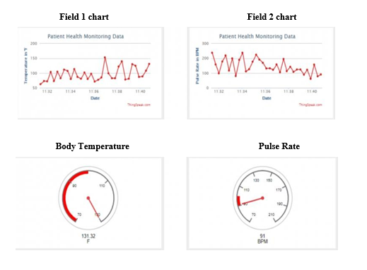

**CHAPTER NO 3**

**PROPOSED SYSTEM**

**INTRODUCTION**

The increased use of mobile technologies and smart devices in the area of health has caused great impact on the world. Health experts are increasingly taking advantage of the benefits these technologies bring, thus generating a significant improvement in health care in clinical settings. Likewise, countless ordinary users are being served from the advantages of the M-Health (Mobile Health) applications and E-Health (health care supported by ICT) to improve, help and assist their health.

According to the constitutions of World Health Organization (WHO) the highest attainable standard of health is a fundamental right for an individual. As we are truly inspired by this, we attempt to propose an innovative system that puts forward a smart patient health tracking system that uses sensors to track patient vital parameters and uses internet to update the doctors so that they can help in case of any issues at the earliest preventing death rates.

Patient Health monitoring using IoT is a technology to enable monitoring of patients outside of conventional clinical settings (e.g. in the home), which may increase access to care and decrease healthcare delivery costs. This can significantly improve an individual's quality of life. It allows patients to maintain independence, prevent complications, and minimize personal costs. This system facilitates these goals by delivering care right to the home. In addition, patients and their family members feel comfort knowing that they are being monitored and will be supported if a problem arises

**3.2 CHARACTERISTICS**

* This Android Based application should work at all times 24 hours around the day.
* This Android Based application must be robust, efficient, and intelligent.
* The application must have user-friendly GUI.

**3.3 SECURITY SYSTEM**

The security of our system will be highly concerned. Our system will provide comfort and secure services.

**3.3.1 Goals:**

* Realtime sensor readings will be recorded
* Easy access.
* No one can change the readings

**3.3.2 Constraints**

* The Interface is provided only in English. So, the user should know English. .
* Registered users only have the rights to access the facilities

**3.3.3 Assumption**

* The developers develop the application by assuming the:
* The user has basic knowledge of computer and its interface.
* The Computer/Mobile has internet connection.
* The user knows English as GUI has been provided in English.

## 3.4 HARDWARE SPECIFICATION:

|  |  |
| --- | --- |
| **RAM:** | 2GB |
| **Hard Disk** | 256GB |
| **Input devices:** | Mouse, Keyboard |
| **Output devices:** | Monitor/LCD |
| **System:** | Intel Core i3 or above |

## 

## 3.5 SOFTWARE SPECIFICATIONS:

|  |  |
| --- | --- |
| **Operating system:** | Window 8, Windows 10 |
| **Front-End:** | XML |
| **Languages :** | Java, Kotlin, C++ |
| **Tools:** | Android Studio |
| **Database:** | SQLite |
| **Browsers:** | Android Real Device |

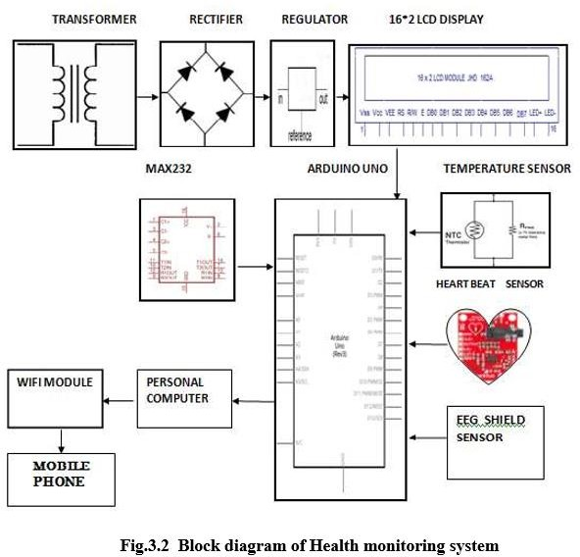

**3.5 MAIN SYSTEM DIAGRAM**

**Figure 3.1**

## 3.6 BENEFITS OF PROPOSED SYSTEM

* Interaction will be easier.
* Users articles can view by others.
* Less time consuming.
* Comments Filtering.
* Job portal.

## 3.6.1 Efficiency

The system will increase the efficiency of work. The record can be inserted, editing efficiently. So efficient work can be accomplished without the wastage of time.

## 3.6.2 Usability

Checking that the system is easy to handle and navigate in the most expected way with no delays.

## 3.6.3 Security

The system will be Secure No one can access other information except admin. The user register to the app has security clearance.

## 3.6.4 Privacy

The “Smart Patients Monitoring Application” shall not search or store/update any personal information about a certain user that cannot be changed by the unauthorized user.

## 3.6.5 Access Rights

The “Smart Patients Monitoring Application” shall not allow the other unknown user to access the database directly or shall not allow making changes in the database.

## 3.6.6 Scalability

Scalability is a critical issue for an Android Application because it can experience heavy traffic from day to day.

## 3.6.7 Maintainability

Admin can easily maintain the whole system as the system is centralized.

## 3.6.8 Testability

To ensure proper testability of the code, we will develop unit tests for all critical parts of the software. Unit tests can be executed automatically to confirm the correct operation of the code after changing parts of the system.

**3.7 PLATFORM COMPATIBILITY**

A wide range of browsers is available now. So, our OP&M should thus support all browsers.

## 3.7.1 Performance

Most of the internet connections still have to deal with lower bandwidths, one of the main focus points for performance considerations should be the amount of display data on one web page. That’s why we have used Bluetooth device for communication even without Internet.

# CHAPTER NO 4

# SYSTEM DESIGN

**INPUT DESIGN**

Flexible and scalable patient’s health monitoring system in Bluetooth HC-05 . The main advantage of this enabling factor is the combination of some technologies and communications solution. The results of Internet of Things are synergetic activities gathered in various fields of knowledge like telecommunications, informatics and electronics.

Maintaining sensing coverage and connectivity in large sensor networks mainly includes the information about how to build or develop a new computational technology based on clinical decision support systems, information processing, wireless communication and also data mining kept in new premises in the field of personal health care.

## INPUT DESIGN FOR A USER SPLASH PAGE

## 

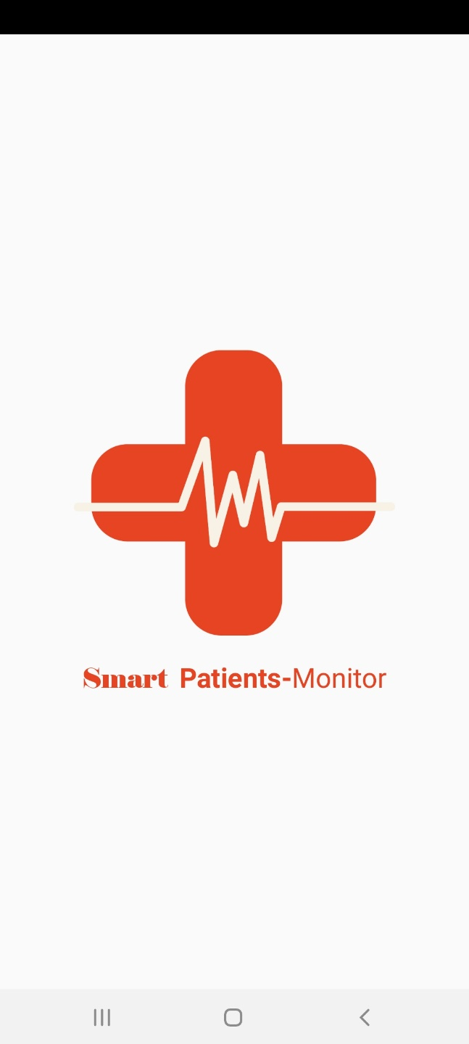

**Figure 4.1**

## INPUT DESIGN FOR A USER START PAGE

## 

|  |  |
| --- | --- |
| Input Name | Enter Data |
| Gender | **User chooses gender** |
| Age group | **User chooses his age group** |

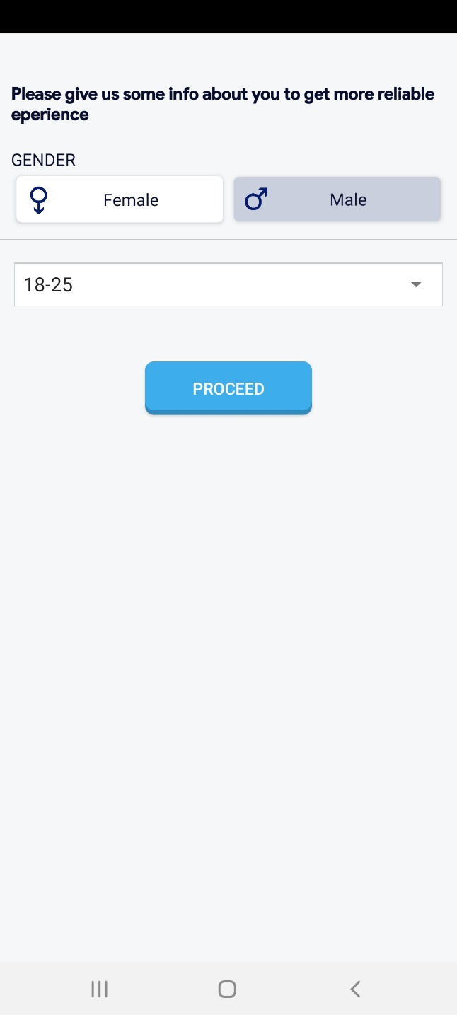

## Devices Screen

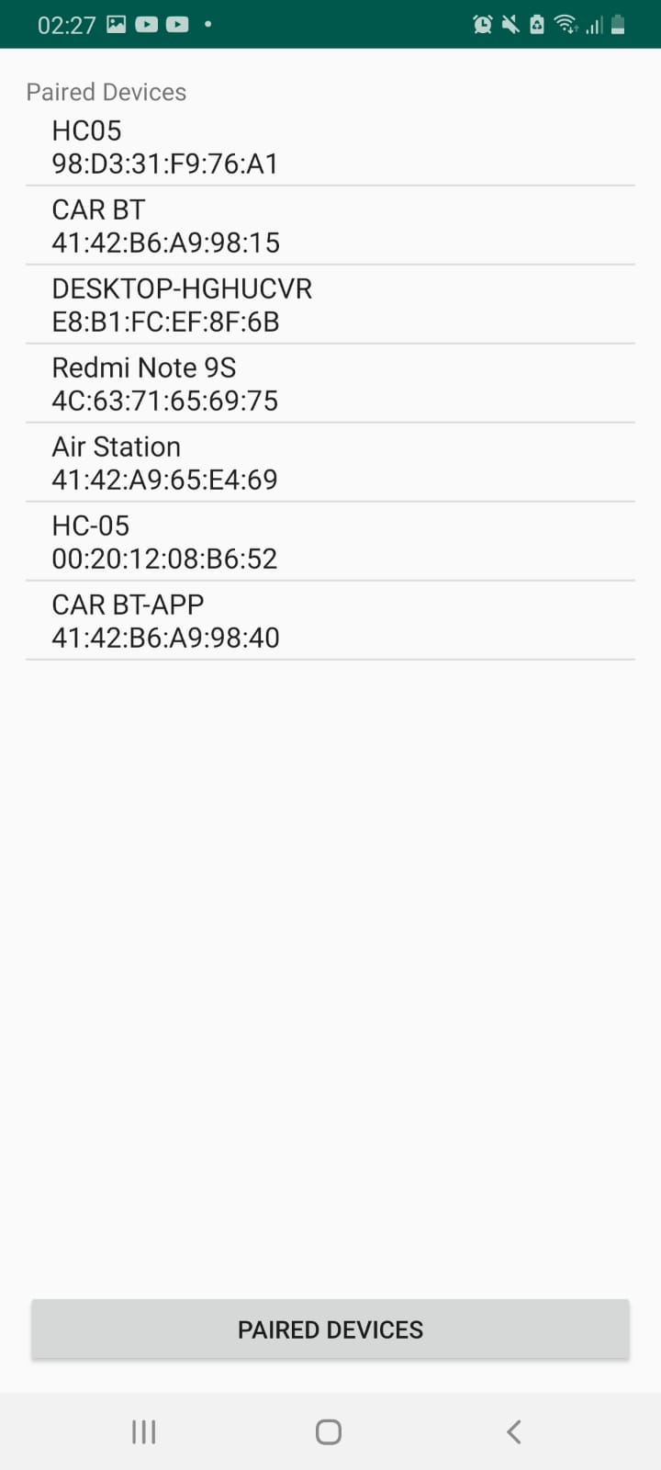

**Figure 4.2**

## DASHBOARD

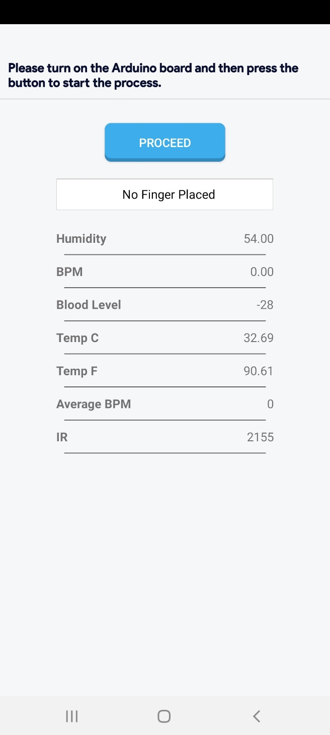

**Figure 4.3**

**4.6 INPUT DESIGN FOR READINGS**

|  |  |
| --- | --- |
| Input | Requirement |
| Thumb | **User places his thumb on sensor** |

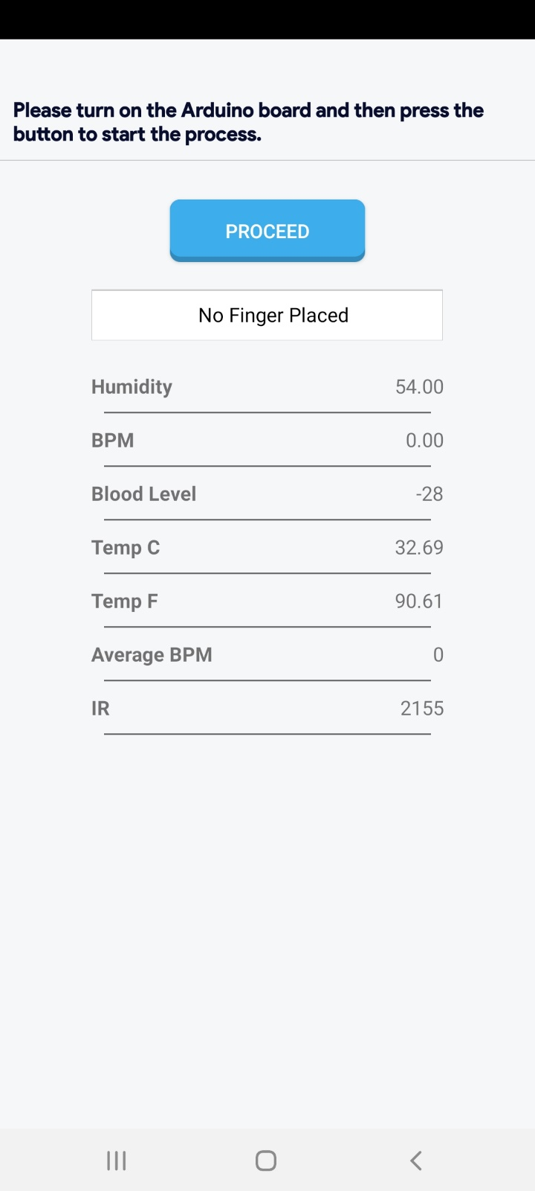

**4.6 USE CASE DIAGRAM**

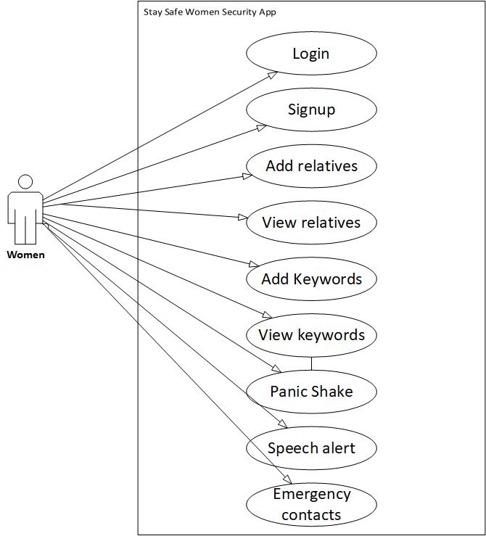

The purpose of this diagram is to demonstrate how objects will interact with our Online Packers & Movers (OP&M) system and map out the basic functionality of the system. Below is a list of the elements that you will see in the diagram on the next page as well what is included in the use case templates that follow.

|  |  |
| --- | --- |
| Actors | Shown in the diagram as stick figures with a name underneath. They represent elements that will be directly interacting with the system. |
| Use cases | Oval shapes that have their names in the center. These represent direct functionality within the system that must be implemented. |
| Interactions | Lines that connect the actors with the different Use Cases. These show that there is some form of direct interaction between the actor and that specific functionality. |
| Type | A field in the use case template that states whether or not the use case is directly interacted with by an actor (Primary) or not (Secondary) as well as whether or not it is essential to having a functioning system. |

**Figure (Smart Patients Monitoring Application) 4.1**

**4.7 USE CASES (FULLY DRESSED)**

## 4.7.1 Admin

|  |  |
| --- | --- |
| **Use case title** | Admin |
| **Use case id** | Case_01 |
| **Description** | Admin can login to the system. |
| **Actors** | Admin |
|  | **Actions** |
| **Co/actor action** | System response |
| **Main Success Scenario** | The Admin Enter Username and password System verifies the admin  Admin is able to login if admin is validated else system doesn’t allow any anonymous user to enter into the system. |
| **Alternative Path** | Nil |
| **Precondition** | Admin is not login in the system. |
| **Post condition** | Admin login into system. |
| **Extension** | Register. |
| **Authors** | Mohsin Saleem , Momin ali |

## 

**4.7.2 PATIENT**

|  |  |
| --- | --- |
| **Use case title** | Patient |
| **Use case id** | Case_02 |
| **Description** | Patient will put his thumb on the device for actual readings. |
| **Actors** | All patients of the hospital. |
|  | **Actions** |
| **Co/actor action** | System response |
| **Main success scenario** | The patient places his thumb so system will allow doctor to view the readings. |
| **Alternative Path** | NILL |
| **Post condition** | Admin is login into the system. |
| **Extension** | System register |

## 

## 4.8 BLOCK DIAGRAM

## 

## Block Diagram Description

The block diagram of the ‘IOT BASED HEALTH MONITORING SYSTEM ‘has following important components as follow

Pulse sensor

Temperature sensor (LM35)

ESP8266(WIFI-module)

Pulse Sensor: -

The Pulse Sensor is a plug-and-play heart-rate sensor for Arduino. It can be used by students, artists, athletes, makers, and game & mobile developers who want to easily incorporate live heart-rate data into their projects. The essence is an integrated optical amplifying circuit and noise eliminating circuit sensor. Clip the Pulse Sensor to your earlobe or fingertip and plug it into your Arduino, you can ready to read heart rate. Also, it has an Arduino demo code that makes it easy to use. The pulse sensor has three pins: VCC, GND & Analog Pin.

LM35 Temperature Sensor: -

The LM35 series are precision integrated-circuit temperature devices with an output voltage linearly-proportional to the Centigrade temperature. The LM35 device has an advantage over linear temperature sensors calibrated in Kelvin, as the user is not required to subtract a large constant voltage from the output to obtain convenient Centigrade scaling. The LM35 device does not require any external calibration or trimming to provide typical accuracies of ±¼°C at room temperature and ±¾°C over a full −55°C to 150°C temperature range.

Bluetooth HC-05: -

It is a very user-friendly and low-cost device to provide internet connectivity to your projects. The module can work both as an Access point (can create connection) and as a station (can connect to Bluetooth), hence it can easily fetch data and upload it to the internet making the Internet of Things as easy as possible. It can also fetch data from the internet using hence your project could access any information that is available on the internet, thus making it smarter.

## 

## 4.10 Circuit/Connection Diagram

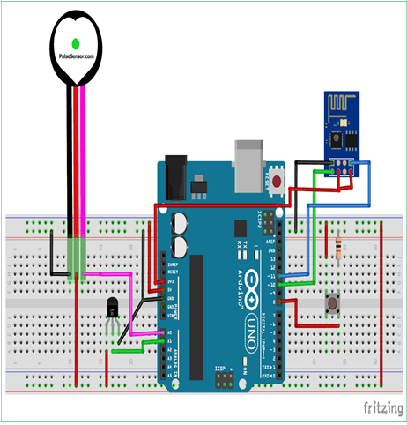

**Figure 4.22**

# CHAPTER NO 5

# SYSTEM IMPLEMENTATIONS

# 5.1 DEFINITION OF IMPLEMENTATION:

A product software implementation method is a blueprint to get users and IOT patient monitoring has 3 sensors. The first one is a temperature sensor, the second is the Heartbeat sensor and the third one is humidity sensor. This project is very useful since the doctor can monitor patient health parameters just by visiting a website or URL. And nowadays many IOT apps are also being developed. So now the doctor or family members can monitor or track the patient’s health through the Android apps.

To operate IOT based health monitoring system project, you need a WIFI connection. The microcontroller or the Arduino board connects to the Wi-Fi network using a Wi-Fi module. This project will not work without a working WIFI network. You can create a WIFI zone using a WIFI module or you can even create a WIFI zone using Hotspot on your smartphone.

The Arduino UNO board continuously reads input from these 3 senses. Then it sends this data to the cloud by sending this data to a particular URL/IP address. Then this action of sending data to IP is repeated after a particular interval of time. For example, in this project, we have sent data after every 30 seconds.

The Arduino UNO board continuously reads input from these 3 senses. Then it sends this data to the cloud by sending this data to a particular URL/IP address.

Then this action of sending data to IP is repeated after a particular interval of time. For example, in this project, we have sent data after every 30 seconds.

5.2 IMPLEMENTATION POINTS:

Some points we need to follow to implement our method such as:

* Developing an Implementation Plan
* Creating an Implementation Plan
* Method for Coding

Implementation is the stage where all the planned activities are put into action. Before the implementation of a project, the implementers (spearheaded by the project committee or executive) should identify their strength and weaknesses (internal forces), opportunities and threats (external forces).

The strength and opportunities are positive forces that should be exploited to implement a project efficiently. The weaknesses and threats are hindrances that can hamper project implementation. The implementers should ensure that they devise means of overcoming them. The project work plan guides implementation and monitoring and monitoring provides information for project planning and implementation.

## 

## 5.2.1 Developing an Implementation Plan

Our implementation plan is based on:

* Determine a timeline for implementation
* Train and educate service providers
* Define roles and responsibilities of service providers
* Develop communication protocols among service providers and the working group
* Develop policies and procedures

## 5.2.2 Time Line for Implementation:

|  |  |
| --- | --- |
| Proposal: | August 2020 |
| Requirement Analysis: | 18 days |
| Requirement gathering: | 10 days |
| Methods for implementing: | September 20120 |
| Coding: | October 2020 – November 2020 |
| Testing: | 12 days |

We have proposed the project in the mid of August 2020. The project timeline to develop is four months, but the strategies and plans for implementation are as below:

**5.2.3 Creating an Implementation Plan**

There are five points for creating an implementation plan:

* Planning for Success
* Doing it Right
* Establishing Timelines
* Delegating Responsibilities
* Monitoring Progress

**5.3 METHODOLOGY:**

**STEP 1:**

The Heartbeat sensor is fixed to the patient’s finger. This contains an IR sensor in it. Every pumping we get pulse from that sensor. This sensor output is given to the Arduino via Signal conditioning unit for amplification

**STEP 2:**

NTC type thermistor is used as a temperature sensor. This temperature sensor output varies based on the temperature; this output is also given to Arduino

**STEP 3:**

EEG sensor is a cost-effective board used to measure the electrical activity of the heart.

This electrical activity can be charted as an ECG or Electrocardiogram output as an analog reading. ECGs can be extremely noisy, the AD8232 Single Lead Heart Rate Monitor acts as an op-amp to help obtain a clear signal from the PR and QT Intervals easily and connected to Arduino.

**STEP 4:**

All these values are transferred to PC via RS 232 and by using the URL, it is transferred to the mobile app created.

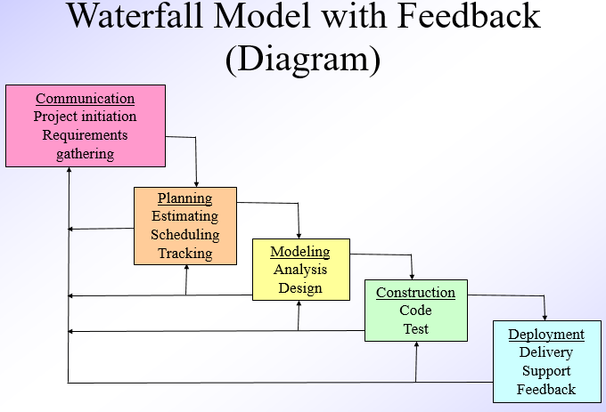

**Figure 5.1**

## 5.3.1 Waterfall Model

The name of this model is justified by the diagrammatic representation which resembles a cascade of a waterfall. It consists with an intuitive set of phases. It has 5 phases:

Requirements

* Design
* Implementation
* Verification
* Maintenance

The different phases starting from feasibility study to integration and testing phase & delivery is known as the developmental pan. At the end of the developmental part, the product is to be delivered to customer and maintenance commences after that.

An activity that spans all phases of any software development is project management. Even though conveniently omitted in the life cycle diagram, project management nevertheless is an important activity in the life cycle and deals with the managing the effort at all stages of product development and maintenance.

## 5.3.2 Analysis

The model enforces discipline in software development process overcoming unstructured code and fixed processes.

* Allow a nicely understood theoretical flow in cascading manner.
* Documented approach, design documentation, code documentation, database manual, operational manual etc.
* Easier to maintain
* Progress is measured by producing crude and executable systems presented to stakeholders and improving them

## 5.4 FEASIBILITY STUDY:

Feasibility studies aim to objectively and rationally uncover Opportunities and threats as presented by the environment, the resources required to carry through, and ultimately the prospects for success. In its simplest terms, the two criteria to judge feasibility are cost required and value to be attained

**5.4.1 Requirement Analysis and Specification:**

The goal of the requirement analysis and specification phase is to understand the customer requirements clearly and to organize the requirements into a specification document systematically.

The main activities carried out during requirements analysis and specification phase are of two types as follows:

**Requirements gathering and analysis Requirements Specification**

The main purpose of the requirements analysis activity is to analyze the collected information to obtain a clear understanding of the product to be developed, to removing all ambiguities, incompleteness, and inconsistencies from the initial customer perception of the problem. The SRS document is the outcome of the requirements analysis and specification phase. There are three main types of problems in the requirements that the analyst needs to identify and resolve:

**INCOMPLETENESS.**

Other steps are discussed accordingly.

**FIVE COMMON FACTORS OF FEASIBILITY STUDY:**

The acronym TELOS refers to the five areas of feasibility - Technical, Economic, Legal,

Operational, and Scheduling

**5.4.2 Technical Feasibility**

Technological feasibility is carried out to determine whether the company has the capability, regarding software, hardware, personnel and expertise, to handle the completion of the project.

**5.4.3 Economic Feasibility**

Economic analysis is the most frequently used method for evaluating the effectiveness of a new system. More commonly known as cost/benefit analysis, the procedure is to determine the benefits and savings that are expected from a candidate system and compare them with costs. If benefits outweigh costs, then the decision is made to design and implement the system. An entrepreneur must accurately weigh the cost versus benefits before taking action**.**

**5.4.4 Legal Feasibility**

Determines whether the proposed system conflicts with legal requirements, e.g. a data processing system must comply with the local Data Protection Acts.

**5.4.5 Operational Feasibility**

Operational feasibility is a measure of how well a proposed system solves the problems and takes advantage of the opportunities identified during scope definition and how it satisfies the requirements identified in the requirements analysis phase of system development.

**5.4.6 Schedule Feasibility**

A project will fail if it takes too long to be completed before it is useful. Typically, this means estimating how long the system will take to develop, and if it can be completed in a given period using some methods like payback period. Schedule feasibility is a measure of how reasonable the project timetable is.

## 5.5 PROGRAMMING ENVIRONMENT:

**5.5.1 Back-End Tools**

* Fire base
* **Java**

**5.5.2 Front End Tools**

* **XML**

**5.5.3 Development Tool**

* **Android Studio**

**5.5.4 Reason for Selecting Firebase**

**Firebase is** a database management system based on The application **is** used for a wide range of purposes, including data warehousing, e-commerce, and logging applications. The most common **use** for **Firebase** however, **is** for the purpose of a Mobile application.

**5.5.5 Reason for Selecting XML, FRONT-END**

Because android always use XML to design front end.

**CHAPTER NO 6**

**SYSTEM TESTING & EVALUATION**

**6.1 TESTING STRATEGIES:**

Testing is a process of executing a program with the interest of finding an error. A good test is one that has a high probability of finding the yet undiscovered error. Testing should systematically uncover different classes of errors in a minimum amount of time with a minimum number of efforts. There are five stages of testing:

* Module or unit testing
* Integration testing
* Function testing
* Performance testing

**6.1.1 Module or Unit Testing**

We have done interfaces tested for proper information flow. Local data are examined to ensure that integrity is maintained. Boundary conditions are tested. Basis path testing is used. All error handling paths should be tested. Drivers and stubs need to be developed to test incomplete software.

**6.1.2 Integration Testing**

* Bottom-up testing (test harness).
* Top-down testing (stubs).
* Modified top-down testing - test levels independently.
* Big Bang.
* Sandwich testing.

**6.1.3 Function/Performance Testing**

Functional testing means testing the application of business requirements. Functional testing executed using the functional specifications given by the client or by imposes the design specifications according to use cases given by the design team. Roles of functional testing are to validating the behavior of an application. There are different test cases that our project’s quality assurance crossed. We have tested our web application through all validations from client end so the user could not get into trouble and will get a friendly interface. We used black box testing for client side.

**6.1.4 Code Testing**

We have used white box testing for the code. It tests internal structures or workings of a program, as opposed to the functionality exposed to the end user. In white box testing an internal perspective of the system, as well as programming skills are used to design test cases. The tester chooses inputs to exercise paths through the code and determine the appropriate outputs. This is analogous to testing nodes in a circuit, e.g., [in-circuit testing](http://en.wikipedia.org/wiki/In-circuit_test) (ICT). Using white-box testing methods, we derived test cases that:

* Guarantee that all independent paths within a module have been exercised at least once
* Exercise all logical decisions on their true and false sides
* Execute all loops at their boundaries and within their operational bounds
* Exercise internal data structures to ensure their validity

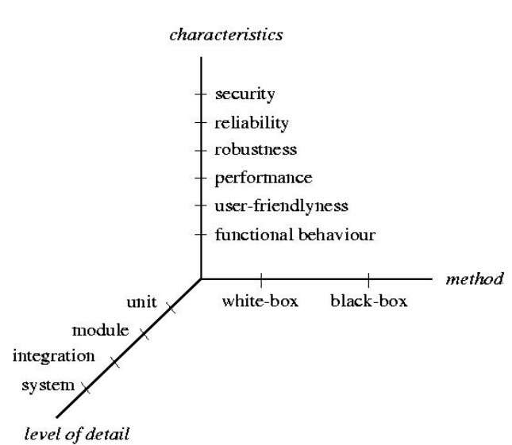

**6.1.5 White Box: Loop-Testing**

* Statement and branch coverage are not sufficient
* Single loop strategy
* Zero iterations
* One iteration
* Two iterations
* Typical number of iterations
* n-1, n, and n+1 iteration (n maximum number of allowable iterations)
* Nested loop strategy:
* Single loop strategy often intractable
* Select minimum values for outer loop(s)
* Treat inner loop as a single loop
* Work ‘outwards’ and choose typical values for inner loops
* Concatenated loops:
* Treat as single, if independent
* Treat as nested, if dependent

**6.2 Project Testing Report**

Testing phase is an important part of software development. It is the process of finding errors and missing operations also a complete verification to determine whether the objects are met and the user requirements are satisfied.

**6.3 SOFTWARE TESTING IS CARRIED OUT IN THREE STEPS**

The **first step** includes unit testing, wherein each module is tested to provide its correctness, validity, and also determine any missing operations and to verify whether the objectives have been met.

Errors are noted down and corrected immediately. Unit testing is the important and major part of the project. So, errors are rectified easily in particular, and program clarity is increased.

**The second** step includes integration testing. It need not be the case, the software whose module when running individually and showing perfect results, will also show the perfect result when running as a whole.

The **final step** involves validation and testing which determines which the software function as the user expected. Here also some modifications were in this completion of the project it is satisfied fully by the end user.

**6.4 MAINTENANCE AND ENHANCEMENT:**

The maintenance phase focuses on the change that is associated with error correction, adoptions required as the software environment involves, and changes due to enhancement brought about by changing customer requirement.

Four types of changes are encountered during the maintenance phase:

* Correction
* Adaptation
* Enhancement
* Prevention

**6.4.1 Correction**

Even with the best quality assurance activities is light that the customer will uncover defects in the software. Corrective maintained changes the software to correct defects.

**6.4.2 Adaptation**

Over time, the original environment for which the software was developed is likely to change. Adaptive maintenance results in a modification to the software to accommodate the change to its external environment.

**6.4.3 Enhancement**

As software is used, the customer/user will recognize the additional functions that will provide benefit. Perceptive maintenance extends the software beyond its original function requirement.

**6.4.4 Prevention**

Computer software deteriorates due to change, and because of this, preventive maintenance often called software re-engineering and must be conducted to enable the software to serve the needs of its end users.

**Post-conditions:**

**The system will authorize an admin to enter into admin dashboard.**

**6.6 USER TRAINING**

In user training, a Proper training session is held with the user to train him/her. For this purpose, live demo will also be run and will be demonstrated with dummy data.

The purpose of this activity is to define the end-user training and documentation strategy and to develop a work plan.

**6.7 CONCLUSIONS**

This is to conclude that the project that I undertook was worked upon with a sincere effort. Most of the requirements have been fulfilled up to the mark and the requirements which have been remaining can be completed with a short extension.

The central concept of the application is to allow the online booking of packing and moving services virtually using the Internet and allow check/search the company to reserve the services offered by the companies.

The server processes the company information and the services are reserved to the time and date along with detailed information. This application was designed into three modules firstly a packing and moving company for the user who wishes to search the company and services are offered to reserve it.

The end user of this platform is the customer where the application is hosted on the web, and an administrator maintains the database.

The application which is deployed at the user database, the details of the packing and moving companies are forwarded from the database for the customer view based on the selection through the website, and the database of all the information is updated at the end of each record.

The proposed system of patient health monitoring can be highly used in emergency situations as it can be daily monitored, recorded and stored as a database. In future the IOT device can be combined with the cloud computing so that the database can be shared in all the hospitals for the intensive care and treatment

**CHAPTER NO 8**

**USER GUIDES**

# 8.1 SPLASH:

**Description:** when the user opens the **Smart Patients Monitoring Application**, the home page

will be displayed where the user can interact with application.

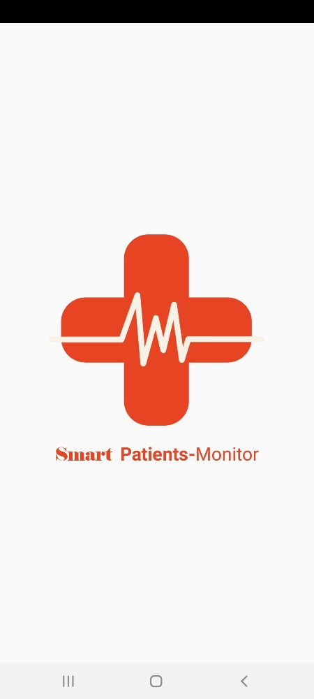

**Figure 8.1**

**8.2 START SCREEN**

**Description:** Here a user gives the necessary information for registration and then verified by the admin.

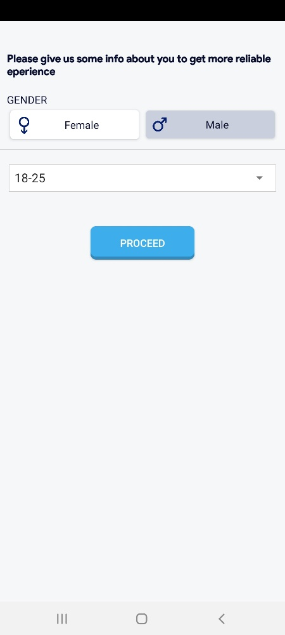

**Figure 8.2**

**8.3 READINGS SCREEN:**

**Description:** The user will see the readings on screen at runtime

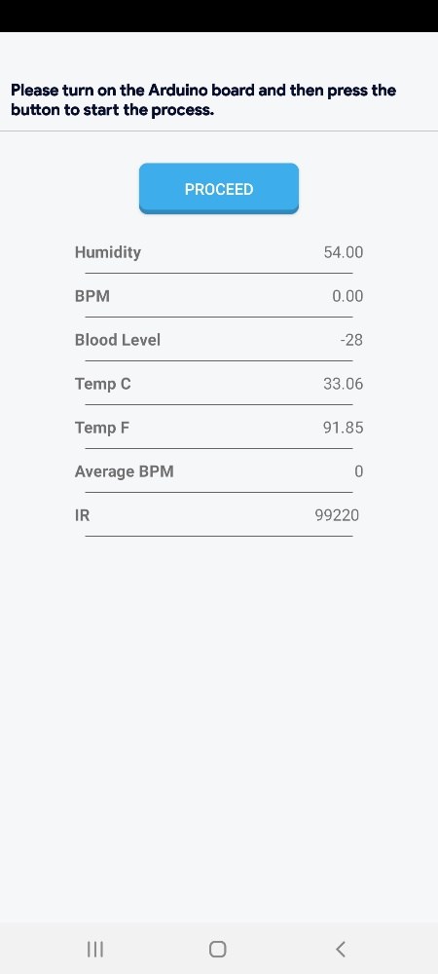

## 8.13 REFERENCE AND BIBLIOGRAPHY

The following links were referred during the analysis and execution phase of the project

**JAVA**

https://www.java.com/en/

**XML JAVA**

https://developer.android.com/studio

**DATABASE**

SQLite

**8.13.1 BIBLIOGRAPHY**

* Roger S. Pressman Software Engineering, a Practitioner’s Approach McGraw Hill Publishing Company Limited, 2009
* Ron Patton, Software Testing 2nd Edition, National Book Foundation

Websites:

* [https://www.projectsof8051.com/arduino-and-iot-based-patient-health-monitoring-system-](https://www.projectsof8051.com/arduino-and-iot-based-patient-health-monitoring-system-%20%20%20project/)
* [project/](https://www.projectsof8051.com/arduino-and-iot-based-patient-health-monitoring-system-%20%20%20project/)
* <https://ieeexplore.ieee.org/document/8441708>
* <https://how2electronics.com/iot-patient-health-monitoring-system-esp8266/>
* [https://circuitdigest.com/microcontroller-projects/iot-based-patient-monitoring-system-](https://circuitdigest.com/microcontroller-projects/iot-based-patient-monitoring-system-using-esp8266-and-arduino)
* [using-esp8266-and-arduino](https://circuitdigest.com/microcontroller-projects/iot-based-patient-monitoring-system-using-esp8266-and-arduino)